TEMPORARY & PERMANENT PUNCTAL PLUGS

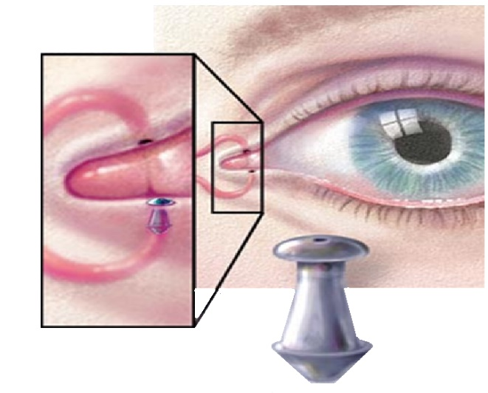

Punctal Plugs help to prevent tears from draining in the back of the throat and maintain moisture in eyes. This helps with burning, teary and dry eyes with sandy sensation. Plugs are inserted into the tear canal to block it, so your own tears stay around longer, keeping eyes moist.

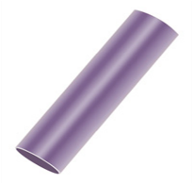
Temporary Punctal Plugs
-Composed of Collagen
-Dissolve 5-7 Days

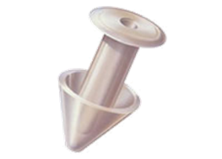

Permanent Punctal Plugs
-Composed of Silicone
-Permanent

Dr Gupta prescribes Artificial tears first, in moderate to severe cases, she does temporary pugs trial in both eyes first, and then once they dissolve and bring relief when they are there, she inserts permanent plugs and does routine checks to ensure they have not fallen out.

