Pterygium
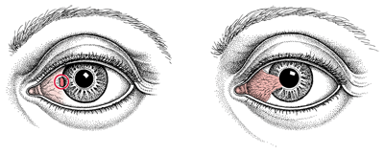

A pterygium is a non-cancerous growth of the clear, thin tissue (conjunctiva) that lays over the white part of the eye (sclera). One or both eyes may be involved.

Symptoms:

The main symptom of a pterygium is a painless area of raised white tissue, with blood vessels on the inner or outer edge of the cornea. Sometimes it may become inflamed and causes burning, irritation, or a feeling like there's something foreign in the eye.

Signs and tests:

A physical examination of the eyes and eyelids confirms the diagnosis. Special tests are usually not needed.

Treatment:
Dr Gupta prescribes Artificial tears, Allergy drops and sometimes steroid drops or ointment which helps when pterygium flares up occasionally.
No surgical treatment is needed unless the pterygium begins to block vision or causes symptoms that are hard to control. Then it should be removed with surgery.
Wear protective sunglasses or transitions and a hat with a brim to prevent the condition from progressing.

