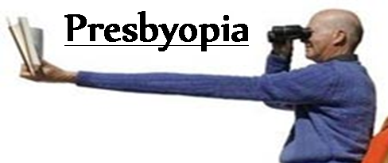

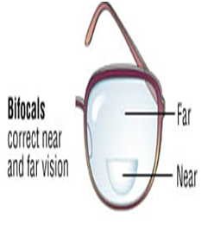
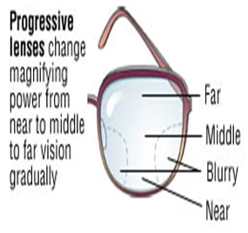

What is Presbyopia?

Presbyopia is a condition in which the lens of the eye loses its ability to focus, making it difficult to see objects up close. This usually occurs when we turn 40. Presbyopia happens from gradual thickening and loss of flexibility of the natural lens inside your eye.

Symptoms: When people develop presbyopia, they find they need to hold books, newspapers, menus and other reading materials at arm's length in order to focus properly. When they perform near work, such as working on a computer or handwriting, they may develop headaches, eye strain, see double upclose or feel fatigued.

Treatment:

Dr Gupta prescribes Bifocal glasses with line,
Progressive: blended glasses, or Single Vision N or Computer glasses per pt’s needs.
Monovision or Multifocal Contact Lenses help.

If the distance vision is good, then there are 2 options:
Either Bifocal with little or no prescription on the top and bottom for reading or the whole lens could be for reading.
Advantage of Bifocal is you don’t have to slide it down on your nose to see Distance better.

